1.

(i) Using the traditional destination-based forwarding, how does a router decides to which output port an arriving packet should be forwarded?

(ii) Which control filed of the IP header can make a packet not be forwarded to more than K routers?

2.

Refer the following SDN OpenFlow network. Show the flow table of S3 for delivering datagrams destined to h5 and h6.

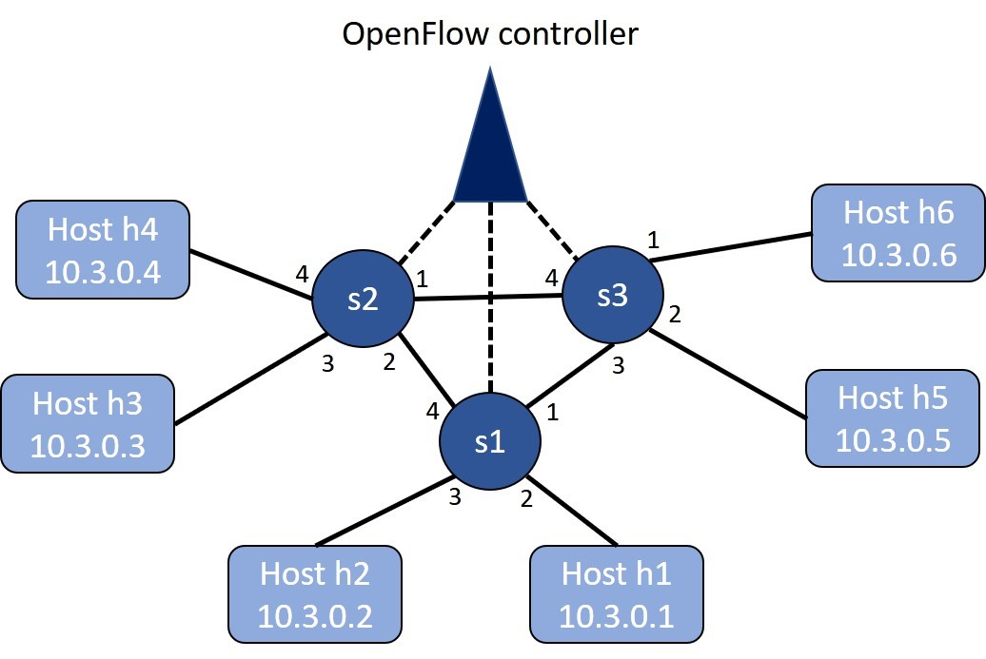

(i)            Datagrams arriving from host h2 and h4 should be delivered to host h5 or h6, but, datagrams arriving from hosts h2 and h5 are blocked.

(ii)           UDP datagrams can be delivered to host h5 or h6, but, TCP traffic should be blocked.

(iii)          Datagrams destined to h5 can be delivered, but, all traffic to h6 are blocked.

(iv)          TCP datagrams from h2 to h5 can be delivered, but, all of the other datagrams are blocked.

3.

(i)A BGP router always choose the shortest AS path length as the default route? True or false and justify your answer.

(ii) Let nodes A, B and C be in the same broadcast LAN. When B sends a data frame that encapsulated an IP datagram to C, in which the C’s MAC address is in the destination address’s field of the data frame. Is node A’s network adapter able to receive and process the data frame? Will A’s adapter pass the IP datagram in the data frame to the network layer A? Justify your answer.

4.

Let nodes A, B, C and D be in the same LAN and use the slotted ALOHA to access the wireless channel. The probability of each node’s transmitting a packet be PA, PB, PC and PD respectively. Let the slot be counted from slot 1. (10%)

A.       What is the probability that node A succeeds for the first time in slot 4?

B.        What is the probability that A, B, C or D succeeds in slot 3?

C.        What is the probability that the first success occurs in slot 3?

D.       What is the efficiency of these four-node channel access?

5.

(i)     There should be no collision using CSMA/CD. True or false and justify your answer.

(ii)    Can the corresponding receivers be able to decode the received data correctly when their peered CDMA senders use (1, 1, 1, -1, 1, -1, -1, -1) and (1, -1, 1, -1, 1, -1, -1, 1) to code their transmitted data? Justify your answer. (10%)

6.

Let two Wi Fi AP1 and AP2 that have different SSIDs but whose signal coverages are overlapped in our CSIE department operate over channel 6 for some reason. What will happen when both APs are transmitting their data frames at the same time?

7.

i)         If RTS/CTS control frame has the same length as the data/ACK frame in the IEEE 802.11 protocol. Does the function of RTS/CTS be still useful for CSMA/CA? Justify your answer.

ii)        When one creates a TCP connection over mobile IP. Can the connection setup phase of TCP between the corresponding node and the mobile node be through the mobile node’s home agent and then the data transmission phase be directly between the corresponding node and the mobile node without the triangle routing problem? Justify your answer.

8.

i) When a wireless host is connecting with a Wi Fi AP, the first action is to send an association request message to the AP. After the wireless host receives the association confirm message from AP, what actions the wireless host will have before having data transmission/receiving through the AP?

ii) For the current multimedia streaming, why is HTTP/TCP-based streaming more popular that UDP-based streaming?

9.

Referring the configuration of video transmission and receiving depicted in the following figure. Let the video server transmit the first video frame on t0, the second video frame on t0 +d , the third video frame on t0 + 2\*d , etc. Let the client playout one video frame for every d time after it enables the playout.

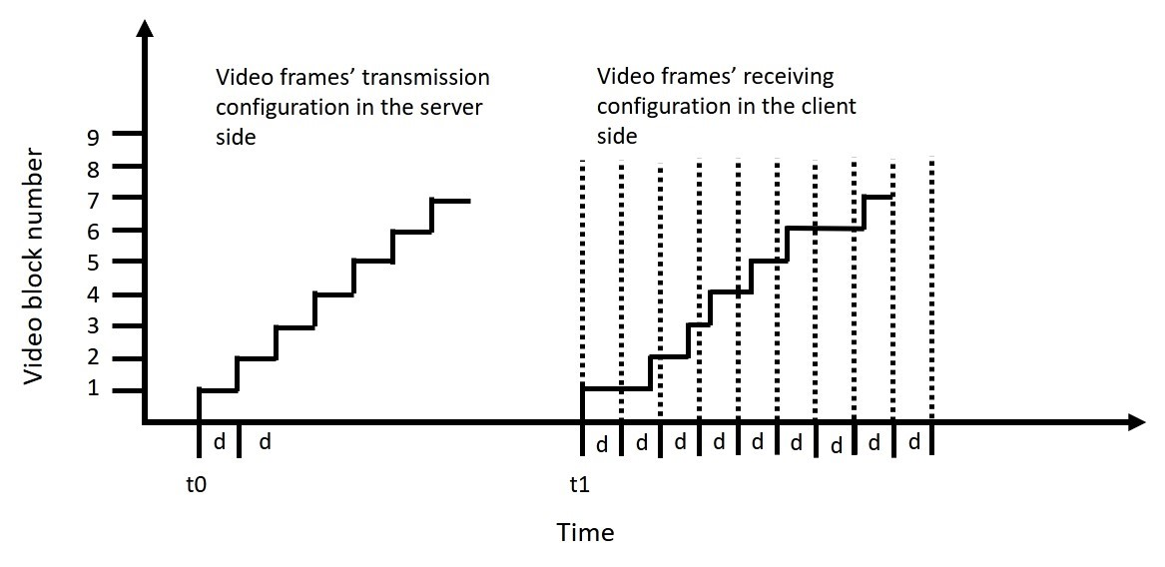

i)   Assume the client enables the playout when it receives the first video frame on t1. Referring the configuration depicted in the following figure, how many video frames, including the first video frame, can the client playout? Justify your answer.

ii)  Assume the client enables the playout on t1+d. How many and which video frames, including the first video frame, can the client playout? Justify your answer.

iii)  For the aforementioned ii) situation, what is the biggest number of video frames that has been stored in the client buffer to wait for playout? Justify your answer.

iv)  What is the smallest commence delay, i.e., the time that the client needs to wait to enable the playout after receiving the first video frame, such that all of the video frames depicted in the following figure can be playout? Justify your answer.

10.

Referring to the following figure of a leaky bucket policer that has a stream of input packets. The token buffer can hold at most two tokens and is full at t = 0. The token’s generating rate is one token per time slot. It needs to consume one token for output one packet. The arrived packets are added in the queue if there is not enough token to forward these arrived packets to the output link. A new token is added to the leaky bucket if it is not full.

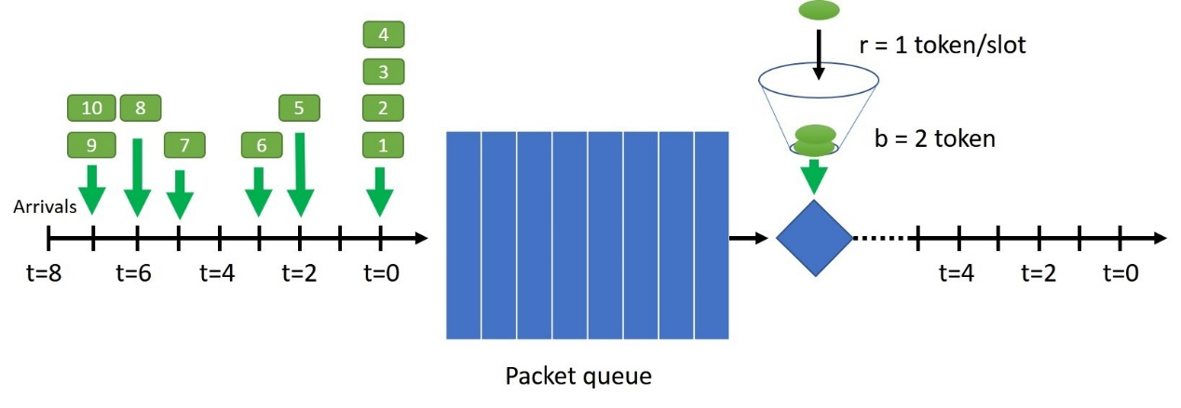

i)        Show the packets that are in the queue and the number of tokens in the leaky bucket from time 0 to time i.

ii)       Show the packets that are in the output link from time 0 to time i.